

CONTACT

+91 9744022806
Shinebabu81@gmail.com
www.shinebabu.com
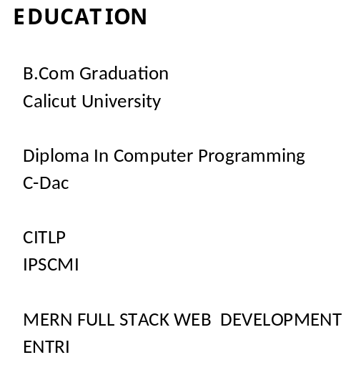
SKILLS

HTML CSS JAVASCRIPT

MongoDB, Express, React, Node,

Full Stack Developer
I am a professional Full Stack Developer with 20 years of experience in Web Project Design, Development and Deployment. Proven ability to convert Client Ideas into Beautiful functional website.
SHINE BABU
WORK EXPERIENCE
TechExps / July 2012 – Present
Senior Web Designer/Developer
As a seasoned senior web developer and designer, I bring over a decade of hands-on experience crafting immersive digital experiences that seamlessly blend creativity with functionality. With a robust background in both front-end development and design, I specialize in translating complex concepts into visually stunning and user-friendly interfaces, ensuring every project exceeds expectations.
ITGuru / jan 2004 – june 2012
Senior Web Designer
With over a decade of experience in the ever-evolving landscape of web design, I've honed my skills to create captivating digital experiences that resonate with users. From concept to execution, my expertise lies in delivering visually compelling designs that elevate brands and drive engagement.
DevTown / Aug 2000 to Dec 2003
Software Developer
I've mastered the art of crafting efficient and scalable solutions to complex problems. My expertise spans across various programming languages and technologies, enabling me to deliver innovative software solutions tailored to meet the unique needs of each project.

COVER LETTER BY
SHINE BABU
Full Stack Developer

